**CHAPTER 1**

**Introduction**

* 1. **Project Problem**

This 'Online Banking' Project is a model Internet Banking Site. This site enables the customers to perform the basic banking transactions by sitting at their office or at homes through PC or laptop. The customers can access the banks website for viewing their Account details and perform the transactions on account as per their requirements.

Internet banking is a product of e-commerce in the field of banking and financial services. In what can be described as business to customer domain for banking industry, Internet banking offers different online services like balance enquiry, balance transfer, opening account, check status etc. Mostly, these are traditional services offered through internet as a new delivery channel.

The Traditional way of maintaining details of a user in a bank was to enter the details and record them. Every time the user need to perform some transactions he has to go to bank and perform the necessary actions, which may not be so feasible all the time. It may be a hard-hitting task for the users and the bankers too. The project gives real life understanding of Online Banking System and activities performed by various roles in the supply chain. Here, we provide an automation for banking system through Internet.

Online Banking System project captures activities performed by different roles in real life banking which provides enhanced techniques for maintaining the required information up to date, which results in efficiency. The project gives real life understanding of Online Banking System and activities performed by various roles in the supply chain.

* 1. **Purpose**

The online internet banking web application is intended to provide complete solution for bank customers/users through a single gateway using the internet as the sole medium. It will enable bank users to withdraw amount, transfer amount and view a mini-statement of the last 5 transactions without having to visit the bank physically.

**1.3 Define scope of the project**

* Quick transaction time and Quick access to bank account.

* Transaction possible throughout the world.
* Secure registration and account management facilities is for customers.
  1. **Product Perspective**

This Project investigates the entry threshold for providing a new transaction service channel via the real options approach, where the entry threshold is established by using an Internet banking system designed for the use of normal users(individuals), Industrialists, Entrepreneurs, Educational Institutions(Financial sections), Organizations and Academicians under transaction rate uncertainty.

This study envisages bridging the gap between the bank and customers. OS is user-friendly, quick to learn and reliable software for the purpose.

**CHAPTER 2**

**METHEDOLOGY**

As per the project management there should be a proper selection of the methodology so on that contrast we have to select the methodology for our project i.e. Online Internet Banking System. Basically there are two types of methodology used for the projects Structured System Analysis and Design Methodology and Object Oriented Methodology. We have chosen Object Oriented Methodology.

* Object Oriented Methodology :

Object-oriented approach combines data and processes (called methods) into single entities called objects. Objects usually correspond to the real things an information system deals with, such as customers, suppliers, contracts, and rental agreements.

Object-oriented model is able to thoroughly represent complex relationships and to represent data and data processing with a consistent notation, which allows an easier blending of analysis and design in an evolutionary process. The goal of object-oriented approach is to make system elements more reusable, thus improving system quality and the productivity of systems analysis and design.

**CHAPTER 3**

**SYSTEM DESIGN**

**3.1 Requirement Analysis**

The main objective of this report is to illustrate the requirements of the project Online Internet Banking Website. The report gives the detailed description of the both functional and non-functional requirements.

**3.1.1 Functional Requirement**

* Functional requirement of the customer is Checking balance, Transfer funds, withdraw and view mini-statement.
* Input is the basic user information.
* The selection of the proper module (Transfer, Withdraw, and Mini-statement) and giving the information of required module.
* Output is displaying the balance, transferring amount to any account number and view mini-statement.
* Contain required information about bank and accounts.
* **User Interface**

The user interface component should be user friendly i.e. easy to understand and access.

It is used to performed common task between bank and customer/user/client.

* **Hardware Interface**

Hardware interface is concern of a communication source between customer and Bank.

It is consult with high speed data transfer rate.

The application required internet facility for communication.

**3.1.2 Non-Functional Requirement**

* **Safety Requirements**

We are going to develop a secured database for the Website. The database may get crashed at any certain time due to virus or operating system failure. Therefore, we have taken every measure by introducing the high-speed reliable CISCO UCS Server with Quad Core Xeon Processor and a backup is taken every 15 minutes into TFTP Server securely. The Backup is then transferred to the cloud service making it more secure.

* **Software Quality Attributes**

The Quality of the database is maintained in such a way so that it can be very user friendly to all the users of the database.

* **Hardware Constraints**

The system requires a database in order to store persistent data. The database should have backup capabilities.

* **Software Constraints**

The development of the system will be constrained by the availability of required software such as web servers, database and development tools.

* **Communication Interface**

Online banking required connection between main server and user and transfer of data between user and system.

**3.2 System Design**

* **UML (Unified Modeling Language)** is standard language of writing software blue prints.

UML is a language that provides vocabulary and rules for combining words in that vocabulary for the purpose of communication.

A modeling language is a language whose vocabulary and rules focus on the concept and physical representation of a system.

The UML is more than just a bunch of graphical symbols. In UML each symbol has well defined semantics. In this manner one developer can write a model in the UML and another developer or even another tools can interpret model unambiguously.

**3.2.1 USE CASE DAIGRAM**

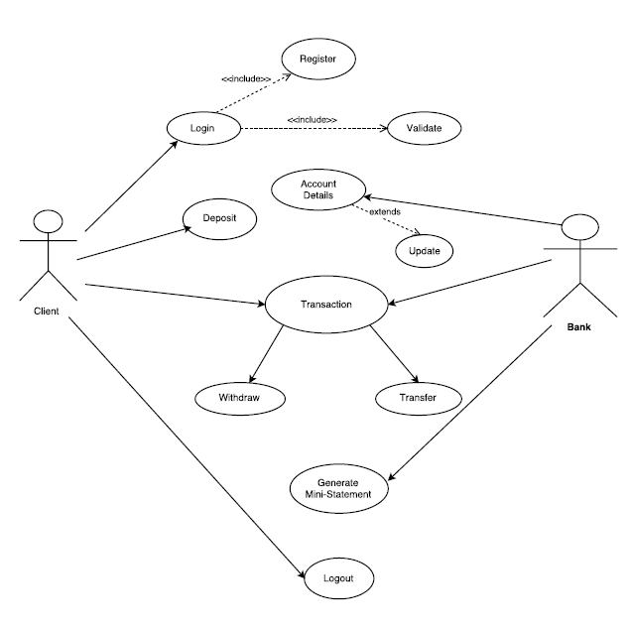

**3.2.2 CLASS DIAGRAM:**

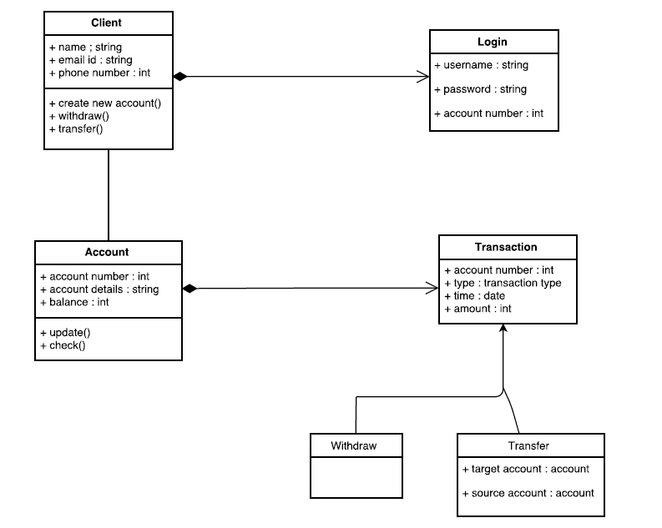

**3.2.3 SEQUENCE DIAGRAM:** 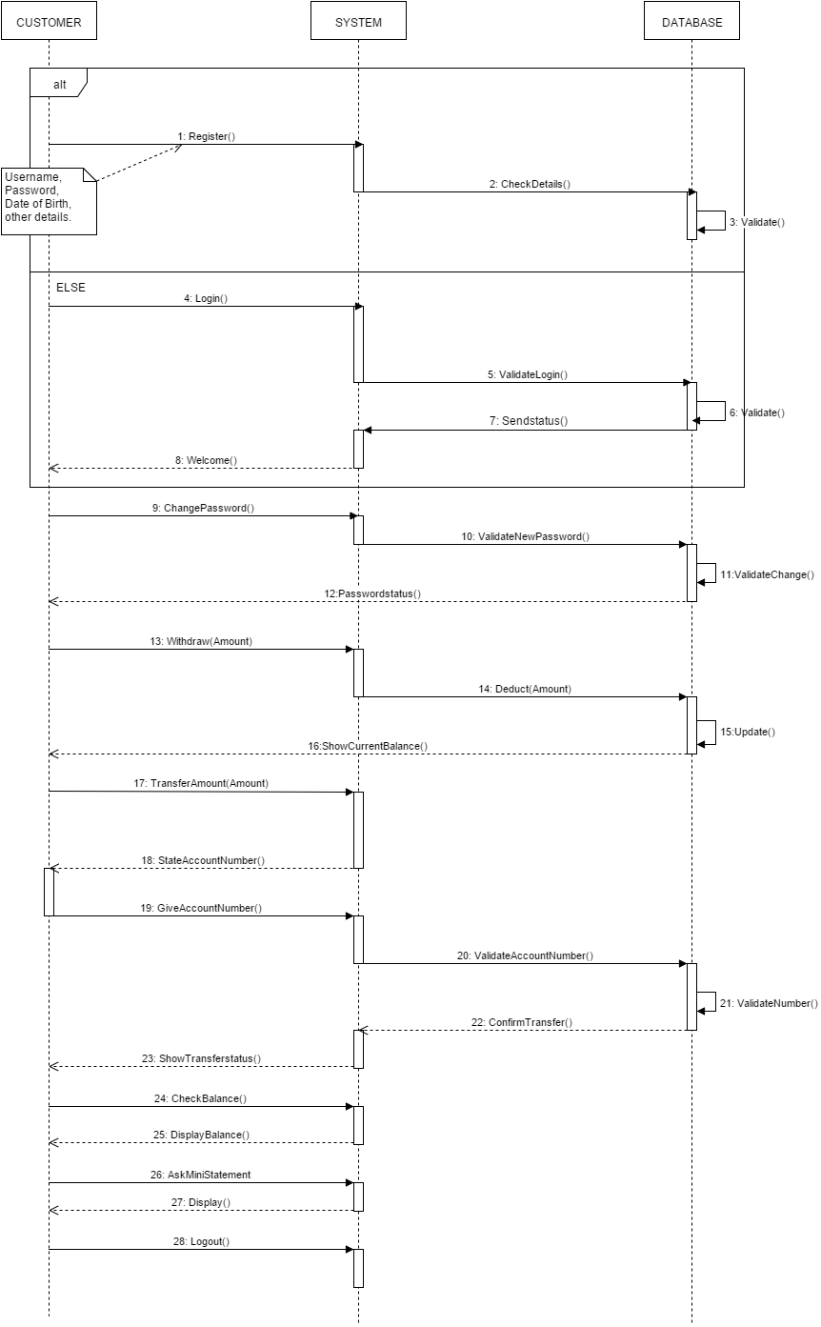

**3.2.4 ACTIVITY DIAGRAM:**

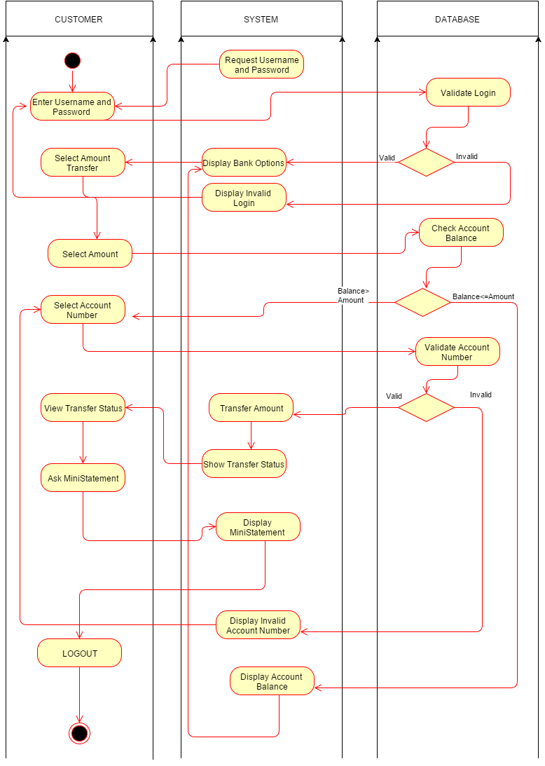

**3.2.5 DATA FLOW DIAGRAM:**

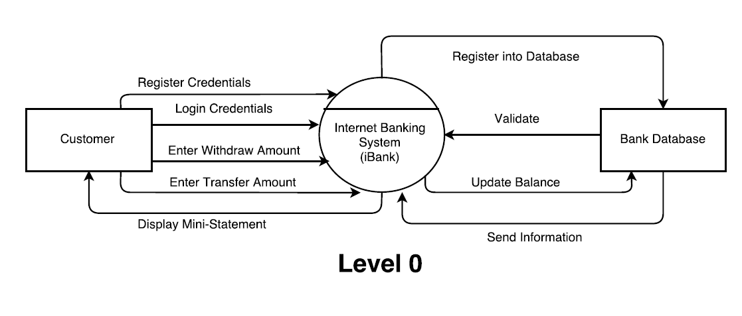

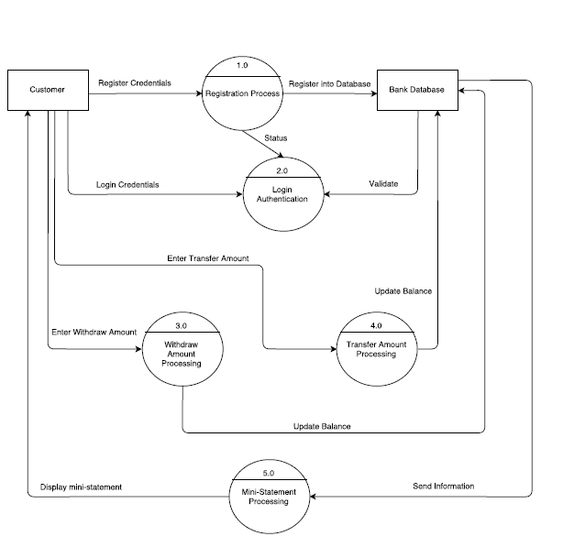

**Level 1**

**Project Snapshots**

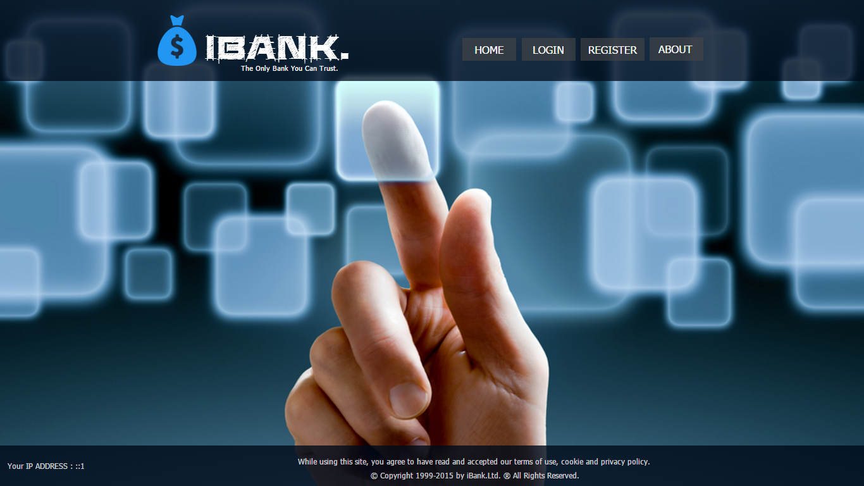

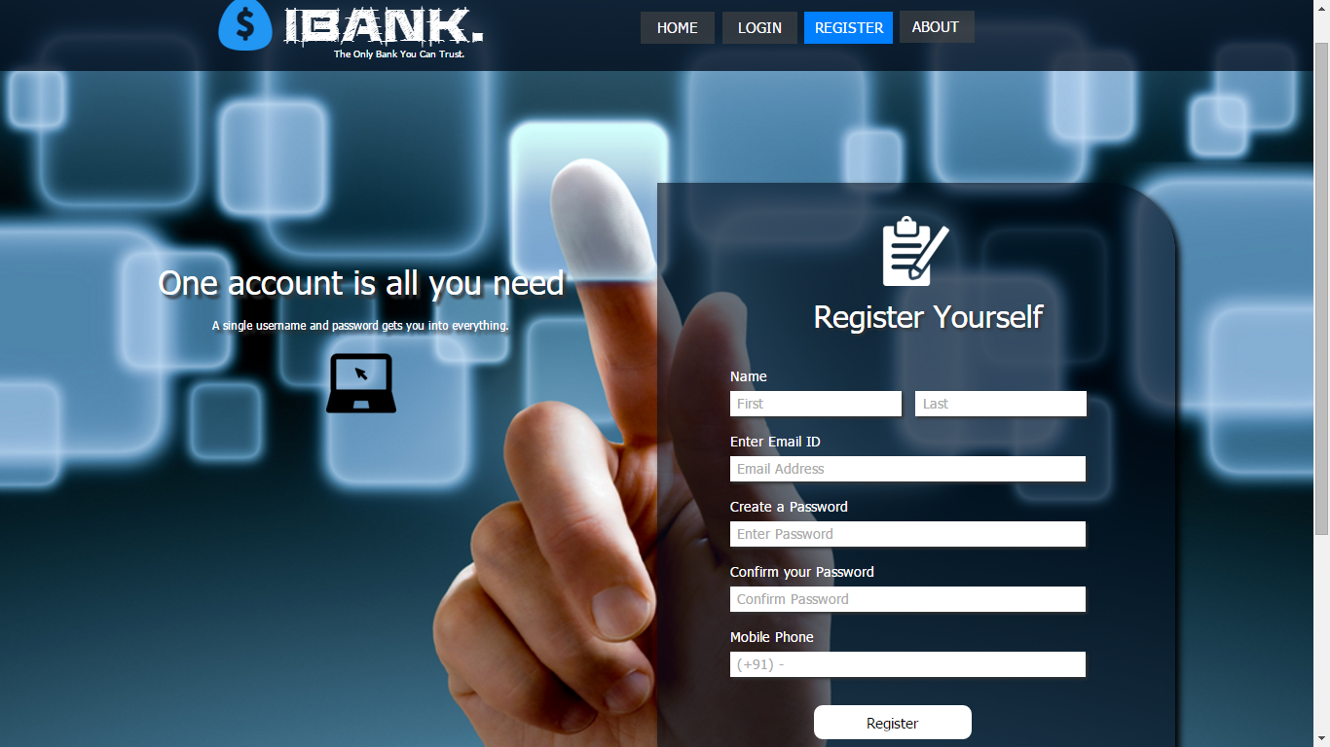

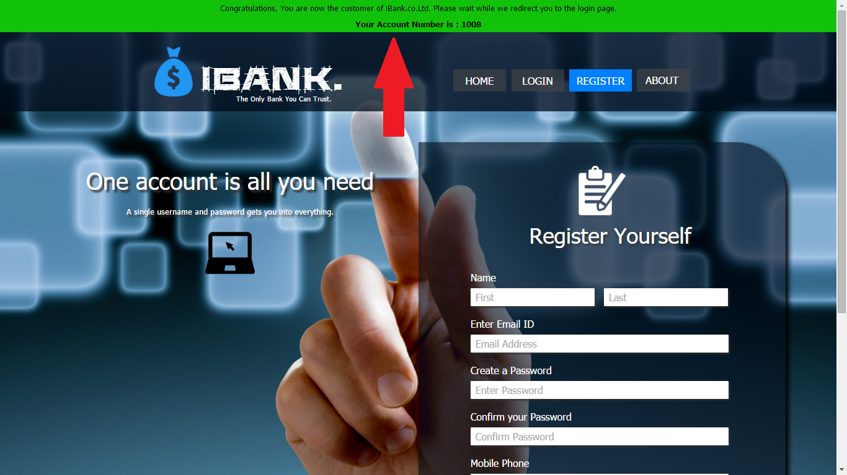

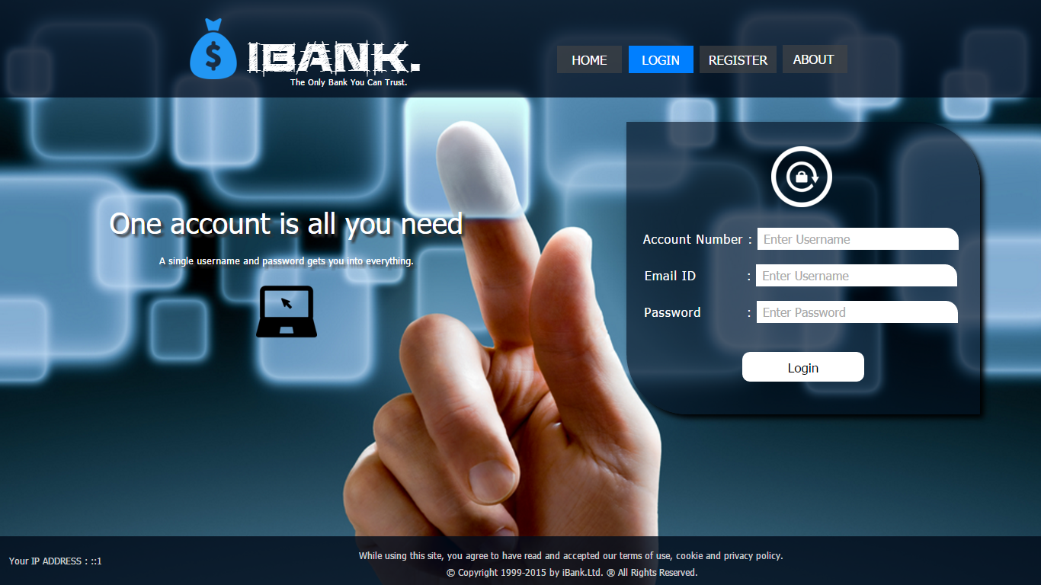

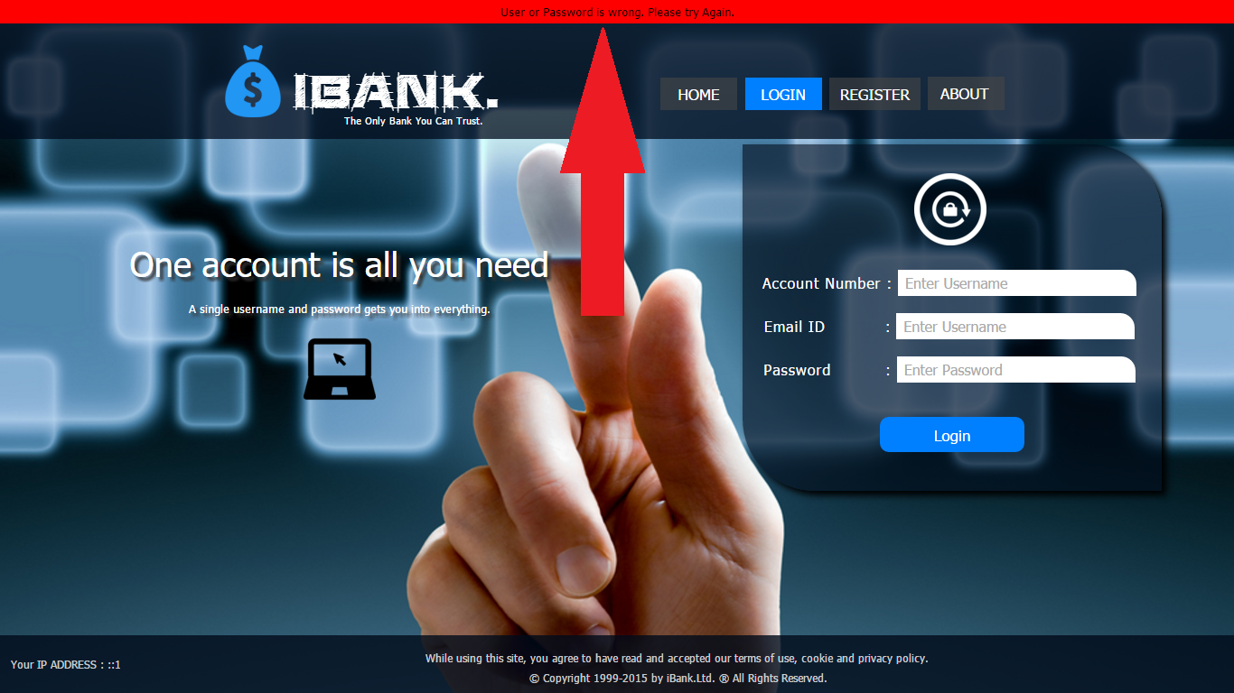

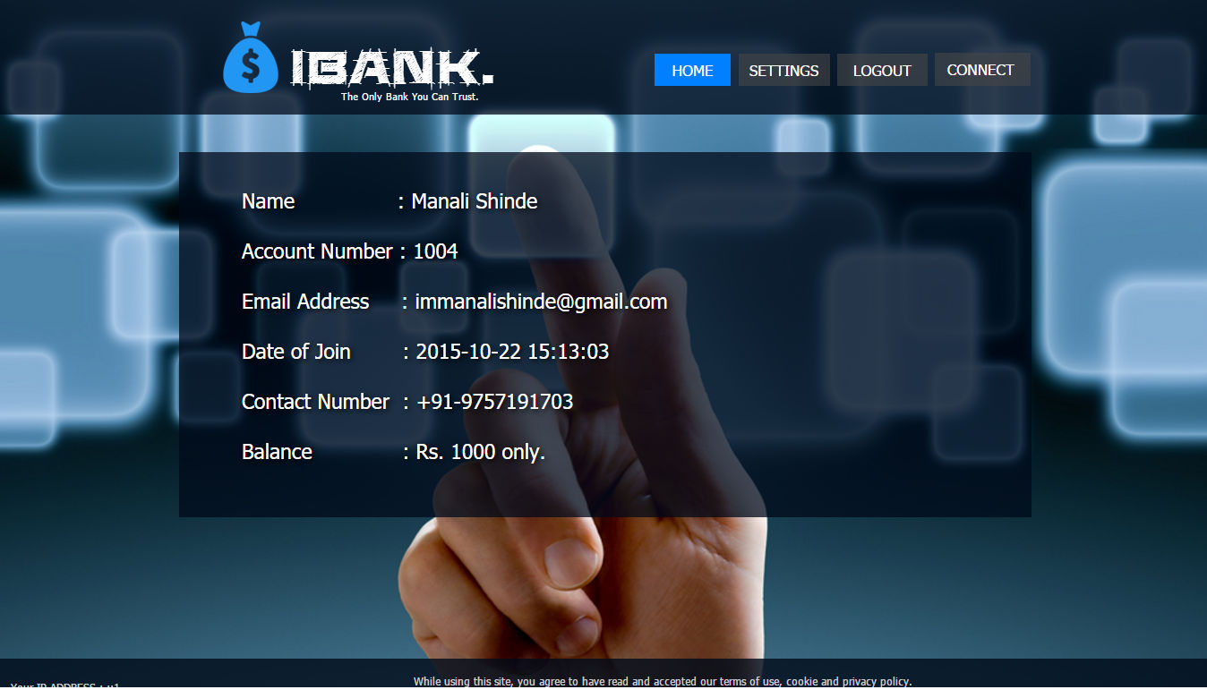

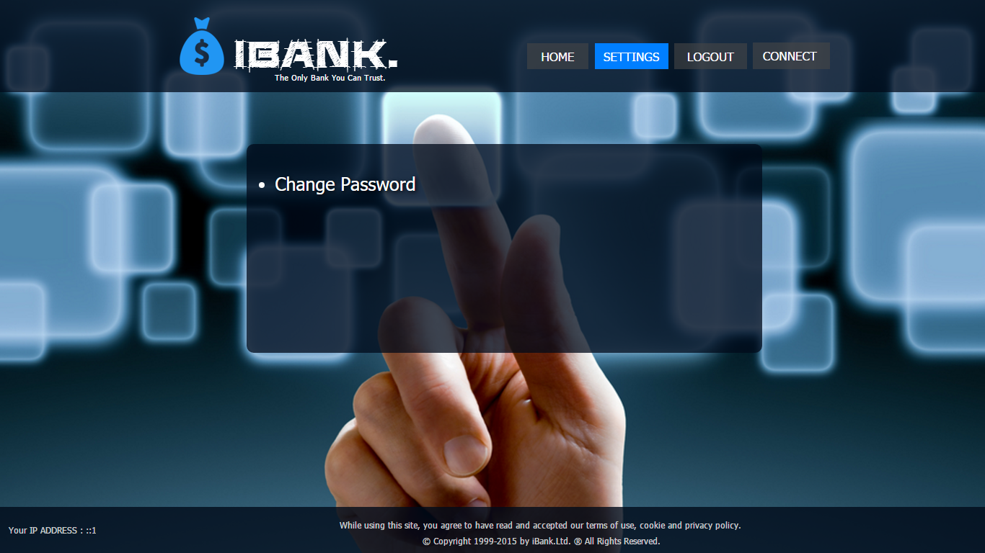

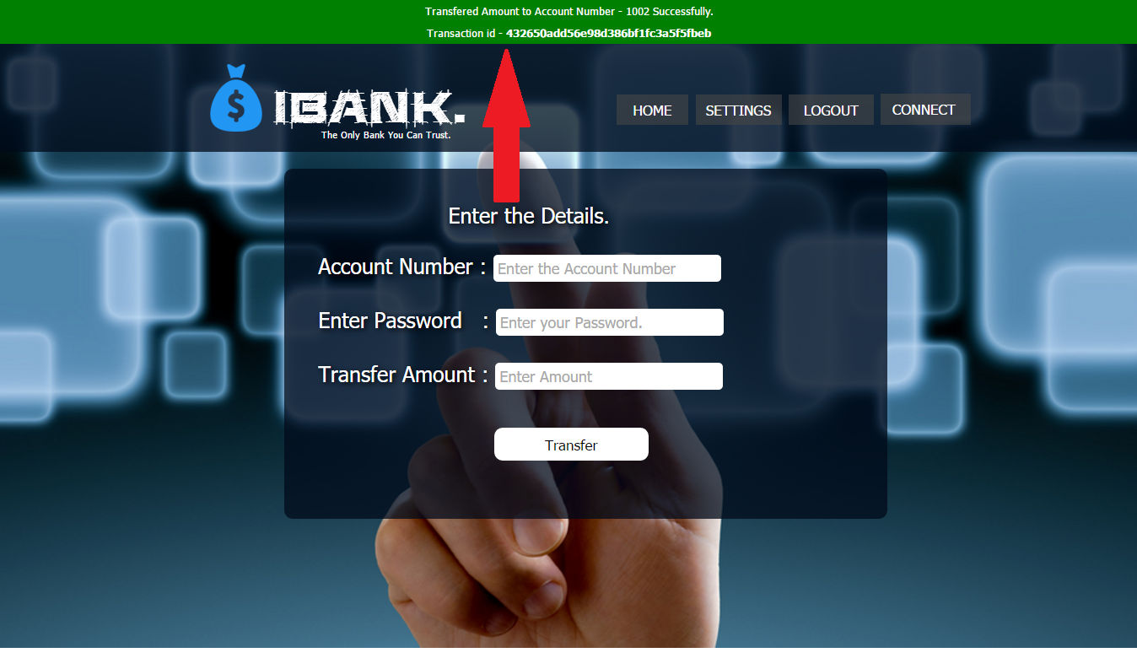

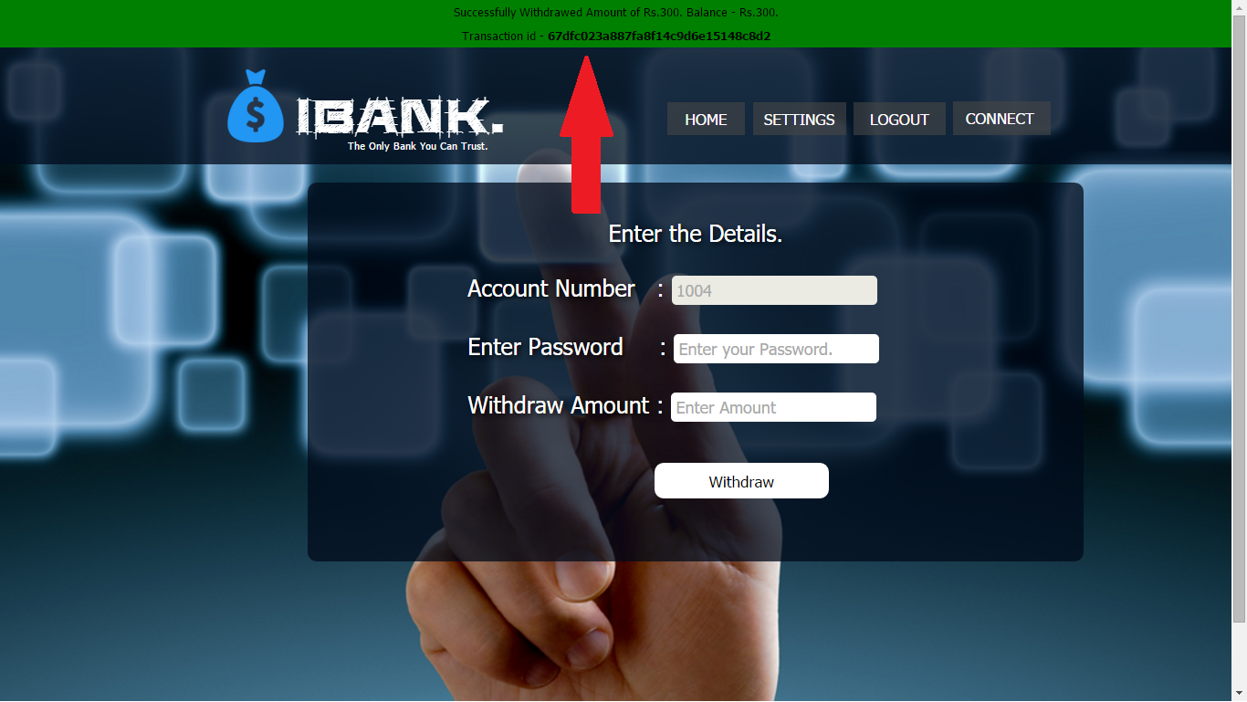

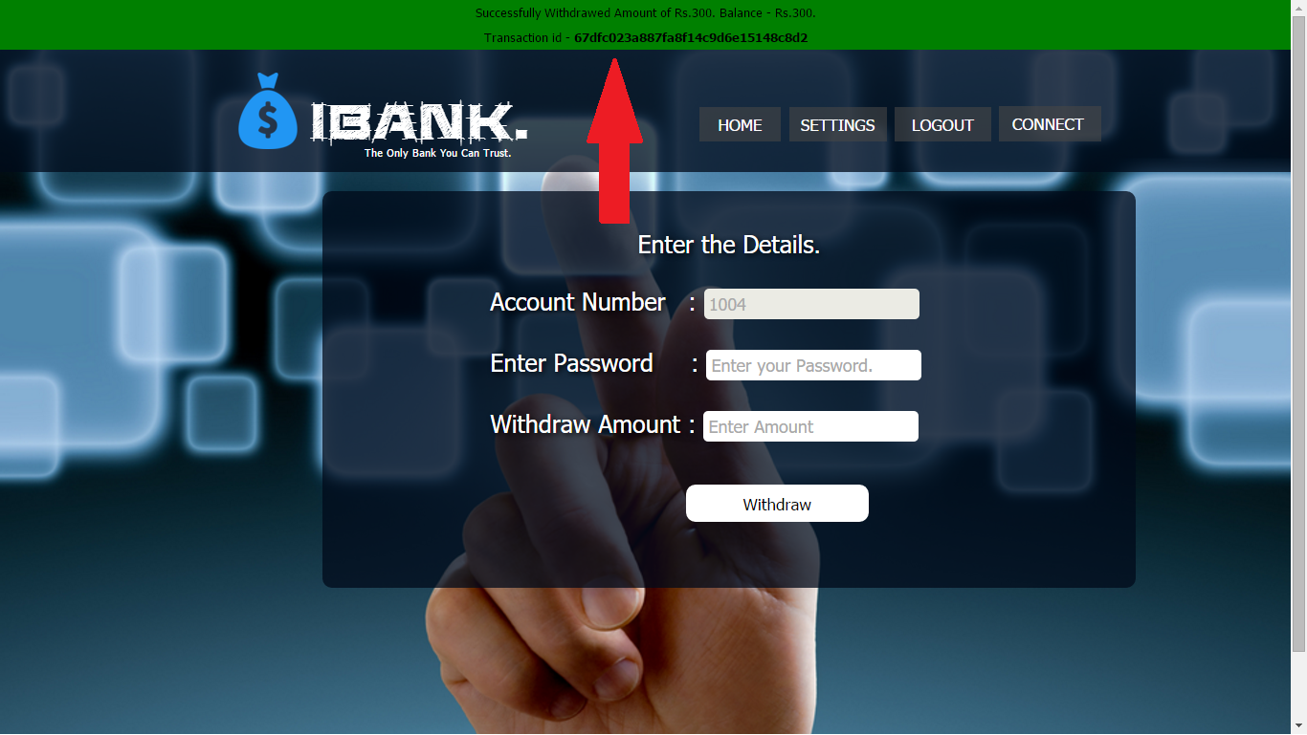

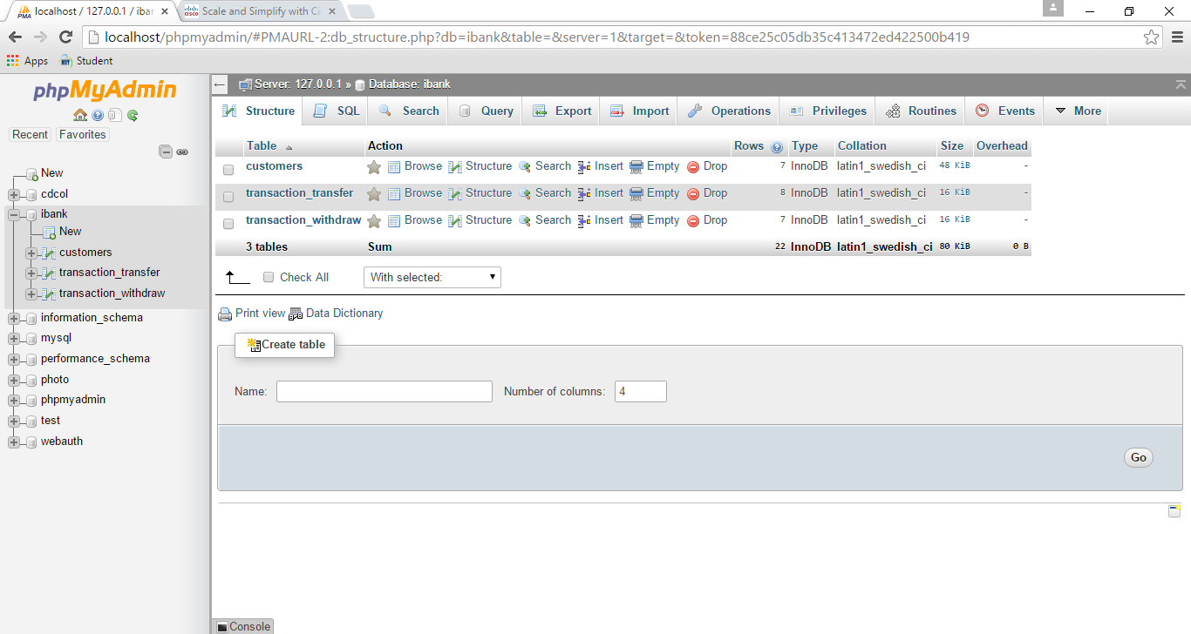

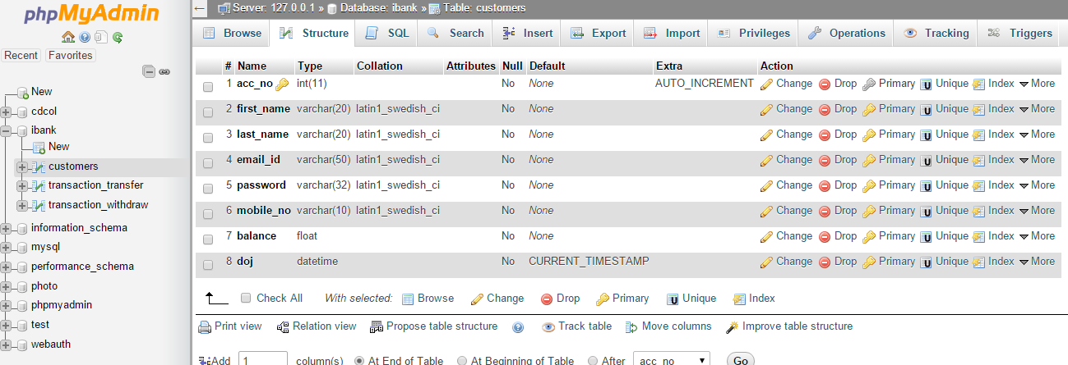

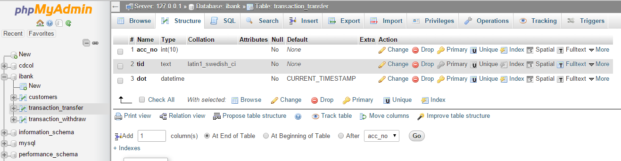

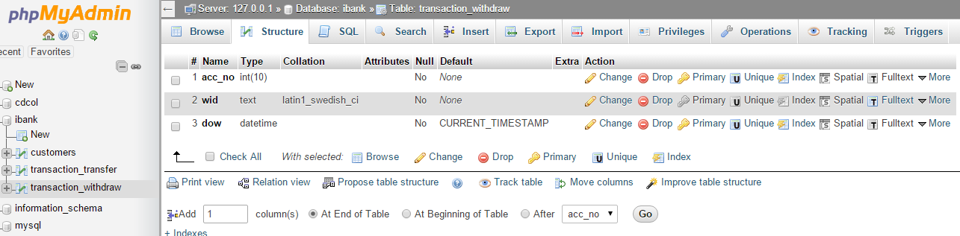

**CHAPTER 4**

**CONCLUSION**

We have successfully completed the online orientation for online banking. The online banking is the best and convenient way for banking and many people choose this as it saves their time.

Online Banking is very advantageous as it is user friendly, quick to access and reliable software.

**Reference**

* *www.icicibank.com*
* *www.sbionline.com*
* *www.online.citibank.co.in*
* *www.sbicard.com*
* *www.mastercard.us*
* *www.hdfcbank.com*
* [*www.google.co.in/*](http://www.google.co.in/)*images*